Town of Portola Valley
Evacuation Plan v1.0 *DRAFT*
July 2023





APPROVAL AND IMPLEMENTATION



Town of Portola Valley
765 Portola Road
Portola Valley, CA 94028
650‐851‐1700
www.portolavalley.net

Original document was provided by the Woodside Fire Protection District and has been edited by the Town of Portola Valley.

Adopted by the Portola Valley Town Council on _______________

RECORD OF CHANGES

Portola Valley
Evacuation Plan

The Evacuation Plan, including appendices, will be reviewed and approved on an as-needed basis. All updates and revisions to the plan will be documented.

The goals of this revision process are:

- to ensure the most recent version of the plan is disseminated and implemented by emergency response personnel;
- to track and thoroughly document all changes.

Refer to Section IV F - Plan Changes and Maintenance below for more information.

TABLE OF CONTENTS

Section Page
APPROVAL AND IMPLEMENTATION 1
RECORD OF CHANGES 2
TABLE OF CONTENTS 3
I. INTRODUCTION 4
A. Overview 4
B. Purpose 4
C. Acronyms and Abbreviations 5
D. Definitions 5
E. Authority 7
F. Associated Evacuation Plans 7
II. ROLES, RESPONSIBILITIES, AND LEVELS 8
A. Evacuation Decisions 8
B. Summary of Evacuation Levels 10
III. EVACUATION OPERATIONS 12
A. Evacuation Routes and Traffic Control 12
B. Emergency Public Information, Dissemination and Communication Tools 13
C. Shelter Requirements 15
D. Shelter in Place and Temporary Evacuation Points 15
E. Transportation 15
F. Non-Resident, Contractor and employee populations 16
G. Animal Evacuations 16
H. Access Control & Security 17
I. Demobilization, Re-entry, Evacuation Order(s) Lifted, Repopulation 17
J. Individual Activities for How to Prepare for an Evacuation 18
IV. ADMINISTRATION AND SUPPORT 21
A. Reporting 21
B. Records 21
C. Resources 21
D. Post Incident Review 21
E. Exercises 21
F. Plan Changes and Maintenance 22
V. EMERGENCY CONTACT LIST 23
APPENDIX 1 - INCIDENT COMMAND SYSTEM (ICS) 24
APPENDIX 2 - SHELTER IN PLACE INFORMATION 28
APPENDIX 3 - TEMPORARY EVACUATION POINTS 29
APPENDIX 4 - LOCATIONS OF SPECIAL FACILITIES 30
APPENDIX 5 - ZONEHAVEN INFORMATION 31
APPENDIX 6 - EMERGENCY GATE LOCATIONS 33
APPENDIX 7 - LIVESTOCK EVACUATION SUPPORT AGENCIES 34
APPENDIX 8 - EVACUATION ROUTES 36

INTRODUCTION

Overview
Evacuation, the protective action of moving people and animals out of harm's way, is a critical aspect of emergency response. It is a process that seeks to preserve life, reduce harm, and minimize property damage during potential or actual threats to a community. In planning for evacuation, the characteristics of the hazard and its magnitude, intensity, speed of onset, and anticipated duration are all significant factors. These will determine the number of people to be evacuated, the distance people must be moved to ensure their safety, the need for reception facilities, and the extent of traffic control and security required.

Thorough preparation ahead of emergency situations, coupled with effective communication throughout the evacuation process, is of utmost importance in ensuring the safety of our community. In Portola Valley, the risk of wildfires and earthquakes present the most likely catalysts for emergency evacuation. Given the geographical layout of Portola Valley with only two main ingress and egress routes - Portola and Alpine Roads - the challenges during an evacuation are amplified due to this limited access. Key establishments that require special attention, such as public schools, numerous preschools, Woodside Priory School, and the Sequoias senior living facility, are situated deep within Portola Valley. These institutions, housing some of our most vulnerable population segments, will require specialized evacuation strategies to ensure the safety and well-being of their occupants during emergency situations.

The community must be prepared to conduct both small-scale (e.g., single facility or limited local) and large-scale (e.g., extensive local and regional) evacuations at all times of the day both from known hazard areas and from unexpected incident locations.

Purpose
The purpose of this plan is to provide for the orderly and coordinated evacuation of all or any part of the population of Portola Valley if it is determined that such action is the most effective means available for protecting the population from the effects of an emergency situation.

This plan is a snapshot of the Town’s current planning and needs to be updated and released frequently as new information is available. During the discussions of the draft of the initial Evacuation Plan, it was identified that an additional chapter and/or appendix needs to be added as soon as possible to provide information for evacuation after an earthquake and possible subsequent events such as wildfire.

We should go back to the good advice from Dwight D. Eisenhower, “In preparing for battle I have always found that plans are useless, but planning is indispensable”. This plan needs to serve as the educational vehicle for the Town and its residents to prepare and practice for an unforeseen emergency hazard which necessitates an evacuation to take place. Our planning needs to keep up with our changing circumstances and understanding.

Acronyms and Abbreviations
CERT  EMC  EOC  ICP  ICS  IC  NRP  NIMS  PIO  REOC  SIP  SMC DEM  SOP  TEP  UC  WFPD | Community Emergency Response Team  Emergency Management Coordinator  Emergency Operations Center  Incident Command Post  Incident Command System  Incident Commander  National Response Plan  National Incident Management System  Public Information Office or Officer  Regional Emergency Operations Center  Shelter-in-Place  San Mateo County Department of Emergency Services  Standard Operating Procedure  Temporary Evacuation Point  Unified Command  Woodside Fire Protection District

Definitions
Evacuation | An organized, phased, and supervised withdrawal, dispersal, or removal of civilians from dangerous or potentially dangerous areas, and their reception and care in safe areas. (The National Incident Management System, NIMS)
Evacuation Warning | Alerting and warning of persons in a defined area of the potential need to evacuate due to threat to life and property in response to an emergency.
Evacuation Order | An order issued by a jurisdictional authority requesting, recommending, or requiring the movement of people and animals out of a defined area due to an immediate threat to life and property from an emergency. The area is lawfully closed to public access.
Shelter-in-Place | Remaining in a location, usually indoors, where hazardous materials are at a safe distance, while taking precautions to minimize exposure to those materials. Prepare to self-sustain until further notice and/or contacted by emergency personnel for additional direction. See Appendix 2 for more information.
Temporary Evacuation Point | A temporary location that an individual or group can go to maximize safety until it is clear to evacuate. Schools, farms, parks, vineyards are good examples of temporary evacuation points that may be able to provide an immediate temporary safe space for people during an emergency or crisis situation until it is safe to evacuate from the immediate hazard. See Appendix 3 for more information.
Demobilization | The process of standing down response resources in an efficient and timely manner providing considerable cost benefits.
Re-entry | The controlled period in which to allow specific residents to Return to or Survey a previously evacuated area or property.
A Re-entry point | An area within a previous evacuation zone where residents may return according to temporary entrance times which are assigned by officials to property owners who are required to abide by stipulations and requirements established by authorities.
Repopulation | The return to areas deemed safe by officials where structures are intact, allowing residents and business owners to move back in for long term habitation.
Evacuation Order(s) Lifted | The formal announcement of lifting evacuations in an area  currently under evacuation.
Special Facilities | Certain facilities which house or serve populations that cannot care for themselves during emergency situations and/or require unique support services. Such facilities include:  - Schools and day care centers, where students require supervision to ensure their safety.  - Retirement and Nursing homes, where patients need specialized health care personnel and equipment to maintain their health.  - Private businesses with large numbers of out-of-town visitors that may not be familiar with evacuation procedures.
Special Needs Populations | Individuals in the community with physical, mental, or medical care needs who may require assistance before, during, and/or after a disaster or emergency after exhausting their usual resources and support network. Special needs populations may also include economically or culturally isolated populations within the community.
Visitor Population | Individuals visiting or staying in a place outside their usual place of residence. Visitor population includes workers, employees and business and leisure travelers present in the jurisdiction, whether for single day or overnight stays.
Zonehaven  (zonehaven.com) | A commercial software application designed to help first responders manage evacuations during an emergency. San Mateo County has purchased Zonehaven and it is now in-use throughout Portola Valley by our public safety agencies to bring fire, law, emergency services and the community together before, during, and after an emergency. Please see Appendix 5 for more information.

Ingress Traffic Road | A designated route or roadway specifically for inbound traffic.

TYPES OF INGRESS TRAFFIC ROAD RESTRICTIONS

- Hard Closure | Closed to all traffic except Fire and Law Enforcement.
- Soft Closure | Closed to all traffic except Fire, Law Enforcement and critical incident resources (i.e., Utility, Caltrans, City/County Roads etc. or those needed to repair or restore infrastructure).
- Resident only Closure | Soft closure with the additional allowance of residents and local government agencies assisting with response and recovery.
- Contraflow | Contraflow is when vehicles travel in the opposite direction of a lane's normal traffic flow. This occurs during an evacuation, when all traffic lanes move toward safety and away from the hazard. This may restrict all Ingress traffic.

Authority
The Incident Command System (ICS) is a standardized, on-scene management approach used for handling any type of incident, regardless of its scale, from inception to resolution. When established the ICS will incorporate all of our emergency response agencies: Woodside Fire, Sheriff, California Highway Patrol, CAL FIRE and the SMC Department of Emergency Management, as well as other involved agencies, departments and public schools. ICS has been the standard for more than 50 years in practice and is used throughout the United States. All of our response agencies have had extensive training and experience in the ICS.
The Incident Commander(s) with jurisdiction from Law Enforcement and/or Fire has the authority to make evacuation and repopulation decisions. The Incident Commander(s) will work in conjunction with local town officials (Mayor, Town Manager, Town Staff, EOC, CERT, and Town Committees). "Incident Commanders" may be identified by any other agencies or entities with responsibility over a population and specific location, i.e., school, park, business, convalescent home, etc. These "ICs" or their designees, during an emergency with evacuations, should report to the incoming or on scene Law or Fire Incident Commander and follow their direction.
You will find more information about ICS in Appendix 1.

Associated Evacuation Plans
All Special Facilities in the town (Schools, Nursing Homes, Special Needs Facilities, and businesses) need to have their own established evacuation and re-entry plans which they educate and practice with their population. The Town, WFPD, Town Emergency Preparedness Committee, and the SMC DEM are assisting with these plans, but the responsibility for creating these separate plans and keeping them up-to-date is the responsibility of the individual facilities.

ROLES, RESPONSIBILITIES, AND LEVELS

Evacuation Decisions
  - The Incident Commander shall assess the need for evacuation, plan evacuations, and coordinate support for the evacuation effort. The Incident Commander has the general responsibility for ordering an evacuation, when deemed the most suitable means of protecting the public from a hazard.

  - Areas to be evacuated will be determined by those officials with the authority to direct a mandatory evacuation based on the counsel of those individuals and agencies with the necessary expertise, the use of specialized planning materials or decision aids, the recommendations of state and federal agencies, and, where appropriate, advice from other subject matter experts. Evacuation recommendations to the public will clearly describe the area to be evacuated with reference to Zonehaven zones and where needed reference to known geographic features, such as roads and streams.

  - The hazard situation which gave rise to the need for evacuation should be continually monitored in case changing circumstances, such as an increase in rainfall or wind shift, changes the potential impact area and, thus, the area that must be evacuated.

  - Authority and Management of an Evacuation - Roles and Responsibilities

- During an incident, many agencies will work together to ensure Portola Valley’s safety.

- The authority to manage such events may start at the local level. By ordinance, the Town has significant responsibilities for emergency preparedness and planning, per Portola Valley Municipal Code Chapter 2.24 (https://library.municode.com/ca/portola_valley/codes/code_of_ordinances?nodeId=TIT2ADPE_CH2.24EMORPR) . Per that authority, in 2017, the Town Council approved an Emergency Operations Plan (EOP) (www.portolavalley.net/community/emergency-preparedness-information/emergency-operations-plan) that provides the basis for municipal operations during a variety of emergency events, including wildfire.) If an ICS is established, primary responsibility will escalate to the Incident Commander, with the Town EOC in a secondary and support role.

- Should an incident start in or near town which involves an Incident Commander, this Incident Commander will assume responsibility for the incident and will notify Town staff, which will activate the Emergency Operations Center (EOC), at Town Hall and/or remotely, to manage its operations with the responsible agencies. The EOC utilizes three systems to manage emergencies across multiple agencies and entities: the Standardized Emergency Management System (SEMS); The National Incident Management System (NIMS), and the Incident Command System (ICS); See Appendix 1.

- The EOC staff does not decide on the declaration of pre-evacuation/evacuation orders; rather, the Incident Commander, based on information from its responsible agencies on scene, and in coordination with the Town EOC will make such determinations.

- Evacuations that must be conducted, because of incidents that occur without warning, may have to be planned quickly and carried out with only those resources that can be mobilized rapidly. Pre-incident planning is critical to identifying probable evacuation areas, routes, resources, and tactical operations. This information must be kept up to date and available to emergency services personnel. Appendix 8 contains the Towns evacuation routes and locations for traffic control. It is critical for mock trial evacuation drills to be executed periodically by the responsible authorities to train and evaluate plans.

  - The Incident Commander, will plan and carry out evacuations and the return of people to their homes or businesses. A large-scale evacuation, however, may require the formation of a regional UC (Unified Command), to support the Incident Command Posts (ICP's) and Emergency Operations Centers (EOC's). This process is well known and practiced in the ICS procedures.

  - Advance Notice of Possible Evacuation (Level 1 and Level 2)

- For slow developing emergency situations, advance warning should be given to affected residents as soon as it is clear evacuation may be required. Warning should address suitable preparedness actions, such as securing property, assembling disaster supplies, fueling vehicles, and identifying evacuation routes (section III describes communication means).
- Warning should be made to special facilities in a threatened evacuation area as early as possible. Such facilities should be requested to review and be prepared to implement their evacuation plans. Facility staff should also report their periodic status and any requirements for assistance to the EOC.
- The special needs population should also be given advance notice. Notifying and preparing this segment of the population for evacuation will likely require additional time and resources. Any special circumstances or requests for assistance should be reported to on-scene authorities or EOC.

  - Official Evacuation Warning (Level 3) or Evacuation Order (Level 4)

- The decision for an official Evacuation Warning or Order will be made by the Incident Commander, based on information from the responsible agencies on scene.

  - Agency responsibilities

- Portola Valley Town Government – the EOC will be staffed by Town staff and/or appropriately trained volunteers; the EOC will coordinate local personnel and assets, provide local information to residents, and keep track of all activity to ensure appropriate emergency reimbursement at a future date.
- Woodside Fire Protection District (WFPD) – serves as the Town’s fire department, and will have responsibility for protecting life, property and the environment through Prevention, Education, Preparedness and Emergency response
- San Mateo County Sheriff’s Office – the Town’s contract police services provider; will inform the community of evacuation orders on-site and manage the evacuation with deputies stationed at critical intersections.
- In larger incidents Cal Fire, California Highway Patrol, and neighboring communities may become included in the ICS.
- San Mateo County Department of Emergency Management – supports the above agencies with expertise and human resources, including the incident command team.

Should an evacuation be called; state law authorizes offices to restrict access to any area where a menace to public health or safety exists (such as a wildfire). Refusal to comply with such orders is a misdemeanor (Penal Code 409.5).

Summary of Evacuation Levels

Level 1 – Slow developing emergency situations/ Red Flag Warning
- High Hazard situation
  - In case of Fire hazard-- No active fire in the immediate vicinity but Red flag Warning has been issued.
- Residents should be prepared during a Level 1 warning to evacuate at short notice. Measures taken should include but not limited to:
  - Parking a car outside the garage facing the street
  - Moving the go bag and other items into the car
  - Regular monitoring of emergency channels.
  - For vehicles powered by gasoline: residents are encouraged to fill up their tanks
  - For electric vehicles: residents are encouraged to keep their battery levels high. See Section III J For more information.
- Consider Early Self Evacuation where possible—this is highly recommended.
- EOC notified or alerted
- Schools and special needs notified

Level 2 – Active Fire Nearby or other disaster
Increased Readiness may be appropriate if there is a greater than normal threat of a hazard which could necessitate evacuation. Level 2 readiness actions may include:

- Review information on potential evacuation areas, facilities at risk, and evacuation routes. Zonehaven platform to be used.
- Alert schools and special needs facilities.
- Monitor the situation.
- Inform local officials and response personnel of the situation.
  - Check the status of potential evacuation routes and shelter/mass care facilities.
  - Consider Early Self Evacuation—this is highly recommended.
  - EOC goes to level 1 or level 2 operation

Level 3 – Official Evacuation Warning
A level of High Readiness as there is an increased risk of a hazard which very shortly may necessitate evacuation. Level 3 readiness actions may include:

  - Monitor the situation.
  - Alert Schools and special needs facilities.
  - Alert response personnel for possible evacuation operations duty.
  - Coordinate with special facilities to determine their readiness to evacuate.
  - Check the status of resources and enhance short-term readiness if possible. Monitor the availability of transportation assets and drivers.
  - Activate all communication means. Advise the public and special needs facilities to monitor the situation.
  - Early Self Evacuation—this is highly recommended, or prepare for imminent evacuation.
  - EOC to level 2 or level 3.

Level 4 – Evacuation Order
Immediately Evacuate selected Zonehaven areas. Activate the EOC to monitor the situation and track resource status.

- EOC to level 3 (EOC itself evacuates if it is in a zone covered by Evacuation Order).
- Activate all communication means. Provide information to the public on planned evacuation routes, securing their homes, and what items they need to take with them.
- San Mateo County Sheriff and other authorities begin informing the community of evacuation orders on-site and manage the evacuation with deputies stationed at critical intersections.
- Check the status of evacuation routes and preposition traffic control devices.
- Alert Schools and Special NeedsFacilities.
- Update plans to move government equipment to safe havens.
- Select shelter/mass care facilities for use.
- WFPD and other fire agencies prepare to defend critical shelter in place facilities.

EVACUATION OPERATIONS

Evacuation Routes and Traffic Control

Evacuation Zones - see also Appendix 5
  - Like many other communities, Portola Valley utilizes Zonehaven (aware.zonehaven.com/search) to organize the community during an emergency. Portola Valley has nine total zones; it is critical that residents know their zone number.

  - Should there be a wildfire, public safety professionals may call individual zones for pre-evacuation noticing and/or evacuation orders, or they may call an evacuation for all Portola Valley zones. See Appendix 5 for more information.

Evacuation Routes - see also Appendix 8
  - In 2022 an initial Emergency Evacuation Traffic Study for Portola Valley of the major evacuation routes for a complete evacuation was completed.

  - Although only studying the major evacuation routes, the evacuation for the entire Human and horse population of Portola Valley and neighboring communities which use these major evacuation routes was included and estimates for evacuation times for various road blockage scenarios were done.

  - The 2022 Emergency Evacuation Traffic study does not include any subsequent housing and population growth after 2022 nor major secondary road traffic analysis scenarios. A single page diagram of these major evacuation routes with the locations for necessary traffic control as well as all Portola Valley neighborhood evacuation routes are in Appendix 8.

  - In 2023 the towns of Portola Valley and Woodside and the WFPD licensed a traffic study analysis software from the company Ladris to further study evacuation traffic capacity (especially on secondary routes). This Ladris software will especially be used in mock evacuation drills done by the town’s responsible agencies. It is crucial that evacuation traffic studies continue and that they include comprehensive traffic analysis of secondary roads and updates reflecting new housing developments and population growth

Traffic control - see also Appendix 8
  - Actual evacuation movement will be controlled by local law enforcement agencies under the direction of the IC. Evacuation routes and the locations for necessary traffic control is in Appendix 8.

  - When possible, two-way traffic will be maintained on all evacuation routes to allow continued access and egress. However, depending on the level and severity of the disaster incoming traffic may be limited only to emergency vehicles and in some situations certain routes may have all lanes turned into exit traffic only. These decisions will be made by the Incident Commander or within the ICS, and with respect to definitions of specific traffic access declarations (Hard closure, Soft Closure, Resident only closure, and Contraflow, see above section I - C Definitions).

  - For large-scale evacuations when time permits, traffic control devices, such as signs and barricades, will be provided by the Public Works/Road Department upon request.

  - Law enforcement will request wrecker services when needed to clear disabled vehicles from evacuation routes.

Emergency Gates - see also Appendix 6
  - The town has a number of gates located on former roads that were closed off to prevent daily traffic problems. These gates can be opened to vehicle traffic during an emergency. Appendix 6 lists these gates and a map in town where these gates are located.

Emergency Public Information, Dissemination and Communication Tools

Communication Tools
The Town and its partners will utilize the following tools to share evacuation messaging:
- SMCAlert – the county’s emergency alert system can be set up to allow for emails, reverse 911 calls to landlines and text messages.
- AM 1680 – the Town’s radio station, which can be updated remotely. This communication means covers almost the entire Town and will be operational during power and phone line failures and in vehicles that have AM radio on route during evacuation.
- PVForum and Next Door
- Town email lists and news updates
- A high-low siren from Sheriff’s vehicles is the approved notice for evacuation. Residents should make themselves aware of the sound.

It is the responsibility of each resident to ensure they are informed by signing up for or having access to the services that will provide emergency information in an emergency. See section J, Individual Activities for How to Prepare for an Evacuation, for more information.

The Incident Commander will evaluate all situations before releasing a warning or evacuation order. Residents should familiarize themselves with the available communications methods and pay close attention to at least two communications channels when an ICS is activated.

Emergency Public Information and Dissemination

  - Warning messages, disseminated through warning systems, alert the public to a threat and provide basic instructions. They are necessarily short and to the point. The public will often require amplifying information on what to do during an evacuation. The Public Information Officer (PIO), assigned by the Incident Commander, will ensure that such information is provided on a timely basis for further dissemination to the public. Provisions must be made to disseminate information to individuals with/that are:
    - Special Needs, including the blind, hearing impaired and non-English speakers
    - Non-Residents/Tourists
    - Education Campus
    - English as a Second Language/Non-English Speakers

  - Amplifying instructions for an evacuation may include information on the location of shelter and mass care facilities, specific evacuation routes, guidance on securing their homes, and the need for evacuees to take certain items with them during an evacuation. When school children are evacuated, parents need timely information on where to pick them up. More information on school evacuation can be found in the individual school evacuation plans.

Advance Notice of Possible Evacuation
    - For slow developing emergency situations, advance notice will be given to affected residents as soon as it is clear evacuation may be required. The advance notice will facilitate suitable preparedness actions, such as securing property, assembling disaster supplies, fueling vehicles, and identifying evacuation routes.

    - Advance notice will be made to special facilities in a threatened evacuation area as early as possible. Such facilities will be requested to review and be prepared to implement their evacuation plans. Facility staff should also report their periodic status and any requirements for assistance to the EOC.

    - The special needs population will also be given advance notice. Notifying and preparing this segment of the population for evacuation will likely require additional time and resources. Any special circumstances or requests for assistance should be reported to on-scene authorities or EOC.

Evacuation and Evacuation Warning
    - Evacuation status will be disseminated through all available warning systems.

    - In the case of immediate evacuation in and around an incident site, en-route alerting, siren and speaker-equipped vehicles moving through the affected area to notify residents. When possible, two vehicles will be employed—the first to get the attention of the people and a second will deliver the evacuation message. Door-to-door notification will be considered for large buildings and in rural areas where residences may be some distance from the road.

    - Special facilities may be notified directly by on-scene authorities or by the EOC staff. However, if both the incident command staff and the EOC will be making notifications, a specific division of responsibilities for notification should be made so that no facilities are inadvertently overlooked.

    - Law enforcement personnel should sweep the evacuation area to insure all those at risk have been advised of the need to evacuate and have responded. It is the personal responsibility of each and every resident to evacuate. Persons who refuse to evacuate will be left until all others have been warned and then, time permitting, further efforts may be made to persuade these individuals to leave.

Shelter Requirements
Pre-incident planning will consider temporary shelters, short term housing, and long-term housing. Resource and logistical considerations include fixed facility requirements, staffing, food and water, medical supplies, security, triage and medical care, mental health care, and relocation assistance. Because the hazard creating the evacuation may determine which shelters will be used, the exact shelter locations which will be used will be determined by the ICS and disseminated by all communication means including public media.

Shelter in Place and Temporary Evacuation Points
Pre-incident planning will also consider locations for Shelter in place and Temporary Evacuation Points for evacuation situations where town residents cannot evacuate from the town. Appendix 2 of this plan includes information regarding Shelter in Place, and Appendix 3 includes information regarding Temporary Evacuation Points.

Transportation

Individuals
It is anticipated that the primary means of evacuation for most individuals will be personal automobiles. Many people who do not own or have access to vehicles and others will need assistance in evacuating. Those needing assistance should plan and rely on family members and neighborhood groups to evacuate as early as possible.

2. Special Needs Individuals/Populations
It is anticipated that most special needs individuals will need evacuation assistance and transportation. Many special needs care facilities may lack the resources to evacuate, and thus should include a strategy for accomplishing this in their emergency evacuation plans. When possible early evacuation greatly alleviates the difficulty in arranging for this transportation. Appendix 4 lists the special needs facilities in town and their locations.

3. Special Facilities
Portola Valley Public schools do not maintain transportation resources. Private schools and day care centers may also have limited transportation assets. Most other special facilities rely on commercial or contract transportation companies for their specialized transportation needs. Unfortunately, many of these providers cannot provide sufficient equipment to evacuate a sizable facility on short notice. Hence, local governments may be requested to assist in providing transport. Schools have developed plans to close schools in periods of high Hazard such that parents can provide for safe evacuation for their children. When parent evacuation is not possible, schools have identified safe shelter in place locations on site. The schools have developed specific evacuation plans to inform and educate their students and parents for these situations.

4. Short Notice Emergency Transportation
Given the remote and rural characteristics of Portola Valley, short notice emergency transportation may not be a viable option, considering the significant amount of time required to organize and secure such transportation.

Non-Resident, Contractor and employee populations
The community must also consider the non-resident population when planning, conducting, and recovering from disasters or emergencies requiring evacuation. The following are recommended:

- The planning effort to incorporate the expected increase in population due to tourism to anticipate the increase in transportation, shelter, medical resource needs.
- The Town and the EOC to work with employers and residents to develop evacuation and communication plans for this evacuation populace.
- Signs posted at the entry of the town with emergency evacuation information.

Animal Evacuations

House Pet Evacuation
    - Evacuees who go to the homes of relatives, friends or commercial accommodations with their pets normally do not pose difficulties during evacuation. However, evacuees with pets seeking public shelter can create potential problems. For health reasons, pets are not allowed in emergency shelters operated by the American Red Cross and most other organized volunteer groups. However, a number of studies indicate that some people, particularly the elderly, will not leave their homes if they cannot take their pets with them. Loose pets remaining in an evacuated area may also create a public safety concern. Hence, it is desirable to make reasonable arrangements for evacuees who come to public shelters with pets. The Animal Control Officer should coordinate these arrangements.

    - Depending on the situation and availability of facilities, one or more of the following approaches will be used to handle evacuees arriving with pets:

      - Provide pet owners information on nearby kennels, animal shelters, and veterinary clinics that have agreed to temporarily shelter pets.
      - Direct pet owners to a public shelter with covered exterior corridors or adjacent support buildings where pets on leashes and in carriers may be temporarily housed.
      - Set up temporary pet shelters at fairgrounds, and other similar facilities.

Livestock Evacuation - see also Appendix 7
Residents and owners of livestock have the personal responsibility to establish emergency evacuation plans that will be executed in an evacuation. In Portola Valley, where horse ownership is notably extensive, this matter is particularly critical. The evacuation of livestock, especially horses, introduces additional layers of complexity and risk, demanding extra diligence and prior preparation from owners. State and county resources are available to assist in livestock and large animal evacuation, including theSan Mateo County Large Animal Evacuation Group (SMC LAEG, smclaeg@gmail.com, www.smclaeg.org, 650-684-0616). More information can be found in Appendix 7.

Access Control & Security
Security in evacuated areas is extremely important. Those who have evacuated may not be allowed access in the future if their property has been damaged (see re-entry below). Law enforcement will establish access control points to limit entry into evacuated areas and, where possible, conduct periodic patrols within such areas to deter theft by those on foot. To the extent possible, fire departments will take measures to insure continued fire protection.

Demobilization, Re-entry, Evacuation Order(s) Lifted, Repopulation
  - After the emergency incident has been stabilized, the Incident Commander will begin to demobilize certain emergency resources and enter the phase of re-entry and repopulation. Evacuees returning to their homes or businesses in evacuated areas require the same consideration, coordination, and control as the original evacuation.
For limited incidents, the Incident Commander will normally make the decision to return evacuees as is appropriate and safe in conjunction with town officials. For large-scale evacuations, the decision for re-entry and repopulation will normally be made by the Incident Commander in conjunction with town officials, county health personnel and other appropriate authorities, and will be disseminated through the media and all appropriate town communication tools.
However, re-entry and repopulation are dependent on the magnitude of the damage and potential health hazards caused by the emergency incident. In cases of significant damage/health hazard an extended period of time may be required to make evacuated areas safe and re-entry will be allowed only for brief periods of inspection. In these cases of more significant damage, and resulting hazards, re-entry and repopulation plans will be drawn up by all responsible authorities to assist evacuees in returning to their homes and businesses. It may be desirable to implement a permit system to limit access to emergency workers, homeowners, business owners, utility workers, and contractors restoring damaged structures and removing debris.
  - The following conditions should prevail in the evacuated area before evacuees are authorized to return:

    - The threat prompting the evacuation has been resolved or subsided.
    - Sufficient debris has been removed to permit travel and roads and bridges are safe to use.
    - Downed power lines have been removed; ruptured gas, water, and sewer lines have been repaired; and other significant safety hazards have been eliminated. However, utility services may not be fully restored.
    - Structures have been inspected and deemed safe for occupancy.
    - Adequate water is available for firefighting.
    - Until the County Health Officer has removed a health hazard advisory, declaring property is clear of hazardous waste and structural ash and debris, Residents are not permitted to repopulate properties. During a stated health Hazard advisory on a property residents should understand they are entering a hazardous area at their own risk. They should wear protective gear and minimize time of exposure.

  - For repopulation and re-entry, it may be necessary to provide transportation for those who lack vehicles. Traffic control along return routes may also be required.

4. Public information intended for returnees should address such issues as:

    - Documenting damage for insurance purposes.
    - Caution in reactivating utilities and damaged appliances.
    - Cleanup instructions.
    - Removal and disposal of debris.

Individual Activities for How to Prepare for an Evacuation

Develop an Emergency Evacuation Action Plan with your family, including:
  - A designated emergency meeting location outside the fire or hazard area. This is critical to determine who has safely evacuated from the affected area.
  - Several different escape routes from your home and community. Practice these often so everyone in your family is familiar in case of emergency.
  - Have an evacuation plan for pets and large animals such as horses and other livestock.
  - A Family Communications Plan www.readyforwildfire.org/prepare-for-wildfire/get-set/prepare-your-family/ that designates an out-of-area friend or relative as a point of contact to act as a single source of communication among family members in case of separation. (It is easier to call or message one person and let them contact others than to try and call everyone when phone, cell, and internet systems can be overloaded or limited during a disaster.)

Be Prepared:
  - Have fire extinguishers on hand and train your family how to use them (check expiration dates regularly).
  - Ensure that your family knows where your gas, electric, and water main shut-off controls are located and how to safely shut them down in an emergency.
  - Assemble an Emergency Supply Kit (www.readyforwildfire.org/prepare-for-wildfire/get-set/prepare-your-family/) for each person, as recommended by the American Red Cross, and a Go Bag (www.readyforwildfire.org/prepare-for-wildfire/get-set/emergency-supply-kit/) as recommended by WPV-Ready.
  - Maintain a list of emergency contact numbers posted near your phone and in your Emergency Supply Kit.
  - Keep an extra Emergency Supply Kit in your car in case you cannot get to your home because of fire or other emergency.
  - Have a portable radio or scanner so you can stay updated on the fire. AM1680 will be broadcasting evacuation and road updates.
  - Tell your neighbors about Ready, Set, Go! and your Wildfire Action Plan. See www.readyforwildfire.org/prepare-for-wildfire/ready-set-go/ and wpv-ready.org/ for more information.
  - Designate an "Evacuation Buddy" - a neighbor who can grab your Go Bag and pets in the event you are not home, and vice versa.
  - Try to always keep your car gas tank or battery charged with enough travel range to get through an extended evacuation.
  - Make sure your address is clearly visible.
  - Know how to open your garage and/or gate if power fails.

Remember the six “P’s”
- People and Pets
- Papers, phone numbers and important documents
- Prescriptions, vitamins and eyeglasses
- Pictures and irreplaceable memorabilia
- Persona computer hard drives and disks
- “Plastic” (credit and ATM cards) and cash

Pre-Evacuation Preparation Steps
(If there is time—remember early evacuation is the most important thing) the following steps to take in anticipation of an evacuation (either before a pre-evacuation warning or after one is called):

Inside the House
- Have your Emergency Supply Kit and Go Bag ready to go.
- Make sure you know your community’s emergency response plan and have a plan on where to go when it is time to evacuate, and best routes for leaving your location.
- Shut all windows and doors. If you choose to leave them unlocked for firefighter access, be advised that looting has occurred in other evacuation incidents.
- Remove flammable window shades, curtains, and close metal shutters.
- Remove lightweight curtains.
- Move flammable furniture to the center of the room, away from windows and doors.
- Shut off gas at the meter. (Do not turn your gas back on without PG&E present).
- Leave your lights on so firefighters can see your house under smoky conditions.
- Shut off the air conditioning.

Outside the house
- Gather up flammable items from the exterior of the house and bring them inside (patio furniture, children’s toys, door mats, trash cans, etc.) or place them in your pool.
- Turn off propane tanks.
- Move propane BBQ appliances away from structures.
- Connect garden hoses to outside water valves or spigots for use by firefighters. Fill water buckets and place them around the house.
- Don’t leave sprinklers on or water running, they can affect critical water pressure.
- Leave exterior lights on so your home is visible to firefighters in the smoke or darkness of night.
- Put your Emergency Supply Kit/ Go bag in your vehicle.
- Back your car into the driveway with the vehicle loaded and all doors and windows closed. Carry your car keys with you.
- Have a ladder available and place it at the corner of the house for firefighters to quickly access your roof.
- Seal attic and ground vents with pre-cut plywood or commercial seals.
- Patrol your property and monitor the fire situation. Don’t wait for an evacuation order if you feel threatened.
- Check on neighbors and make sure they are preparing to leave.

Animals
- Locate your pets and keep them nearby.
- Prepare farm animals for transport and think about moving them to a safe location early.

Evacuation Tips
  - Complete any pre-evacuation steps as time allows.
  - Monitor communications for the most up-to-date-information especially AM radio 1680 (more information is section IIIB1).
  - Ensure your Emergency Supply Kit/Go Bag is in your vehicle.
  - Whether you are evacuating due to severe weather or wildfire, it is important to protect your body from the elements – For a wildfire cover-up to protect against heat and flying embers. Wear long pants, long sleeve shirt, heavy shoes/boots, cap, dry bandanna for face cover, goggles or glasses. 100% cotton is preferable.
  - Locate your pets and get them ready to take with you.
  - Evacuate early.

ADMINISTRATION AND SUPPORT

Reporting
Large-scale evacuations should be reported to state agencies and other jurisdictions that may be affected in the periodic Situation Reports prepared and disseminated during major emergency operations.

Records
  - Activity Logs. The Incident Commander and, if activated, the EOC shall maintain accurate logs recording evacuation decisions, significant evacuation activities, and the commitment of resources to support evacuation operations.

  - Documentation of Costs. Expenses incurred in carrying out evacuations for certain hazards, such as radiological accidents or hazardous materials incidents, may be recoverable from the responsible party. Hence, all departments and agencies will maintain records of personnel and equipment used and supplies consumed during large-scale evacuations.

Resources
General emergency response resources that may be required to conduct an evacuation are listed in the Portola Valley Emergency Operations Plan, and include the following:

- Resource Identification
- Coordination with Other Jurisdiction
- Resource Management
- Private Coordination
  - Special needs Health Care
  - Schools and Daycares
  - Business
- Donation Tracking and Volunteer Management
- Relocation Assistance

Post Incident Review
For large-scale evacuations, the Town of Portola Valley shall organize and conduct a review of emergency operations by those tasked in this plan in accordance with the guidance provided in the Portola Valley Emergency Operations Plan EOP. The purpose of this review is to identify needed improvements in this plan, procedures, facilities, and equipment.

Exercises
Local drills, tabletop exercises, functional exercises, and full-scale exercises shall periodically include an evacuation scenario based on the hazards faced by Portola Valley.

Plan Changes and Maintenance
  - The Town of Portola Valley is responsible for developing and maintaining this plan. Recommended changes to this plan should be forwarded as needs become apparent.
  - Departments and agencies assigned responsibilities in this plan are responsible for developing and maintaining SOPs covering those responsibilities.
  - All Special Facilities in the town (Schools, Nursing Homes, Special needs facilities, and businesses) need to have their own established evacuation and re-entry plans with which they educate and practice with their population. The Town, WFPD, Town Emergency Preparedness Committee, and the SMC DEM are assisting with these plans, but the responsibility for creating these separate plans and keeping them up-to-date is the responsibility of the individual facilities.

EMERGENCY CONTACT LIST

Agencies | Contact | Office Phone Numbers
California Division of Homeland Security & Emergency Management | State Emergency Coordination Center | (916) 845-8510
California River Forecast Center | Hydrologist | (916) 979-3056
California Dept. of Commerce, Community & Economic Development | Flood Insurance Program | (800) 397-3240
California Dept. of Environmental Conservation | Disaster Coordinator (primary) | (916) 323-2514
American Red Cross, California Office | Disaster Services | (415) 427-8000
CHP - California Highway Patrol | (Local or Regional Office) | (800) 835-5247
California Dept. of Conservation | Main phone line | (916) 445-0732
California Army National Guard | Headquarters: | (916) 854-3000
California Air National Guard: | Headquarters, Camp: | (916) 854-3000
National Weather Service | Web | https://www.weather.gov/
FEMA - Federal Emergency Management Agency | Customer Service number. | (800) 621-3362
WFPD - Woodside Fire Protection District | Main phone line | (650) 851-1594
Town of Portola Valley | Main phone line | (650) 851-1700
CAL FIRE - California Department of Forestry and Fire Protection | Main phone line administration | (650) 573-3846
Cal Water - California Water Service | Main phone line | (650) 854-5454
Caltrans - California Department of Transportation | Main phone line | (916) 654-5266
PG&E - Pacific Gas & Electric | Main phone line | (800) 468-4743
West Bay Sanitary | Main phone line | (650) 321-0384

Personal / Agency Name | Frequency/Channel | Phone Number

APPENDIX 1 - INCIDENT COMMAND SYSTEM (ICS)
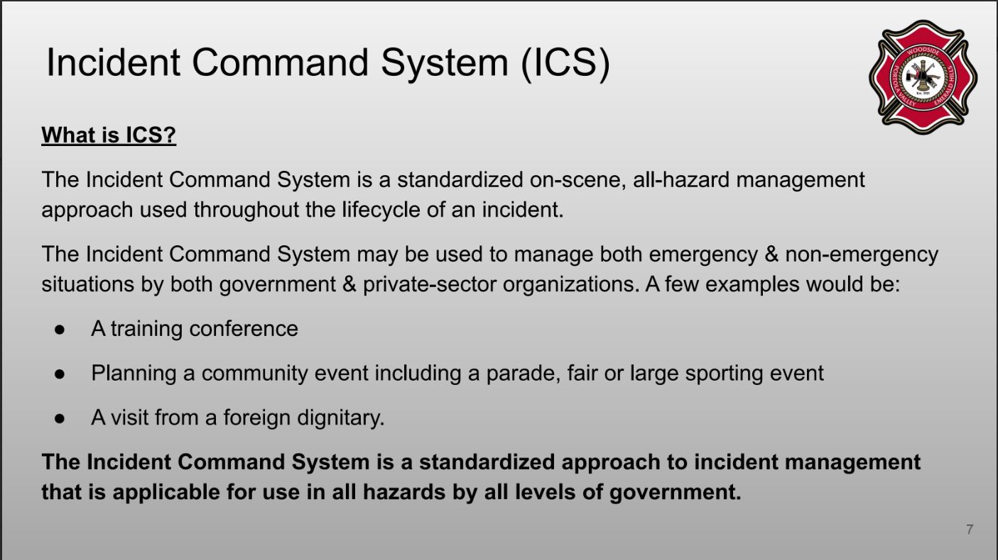

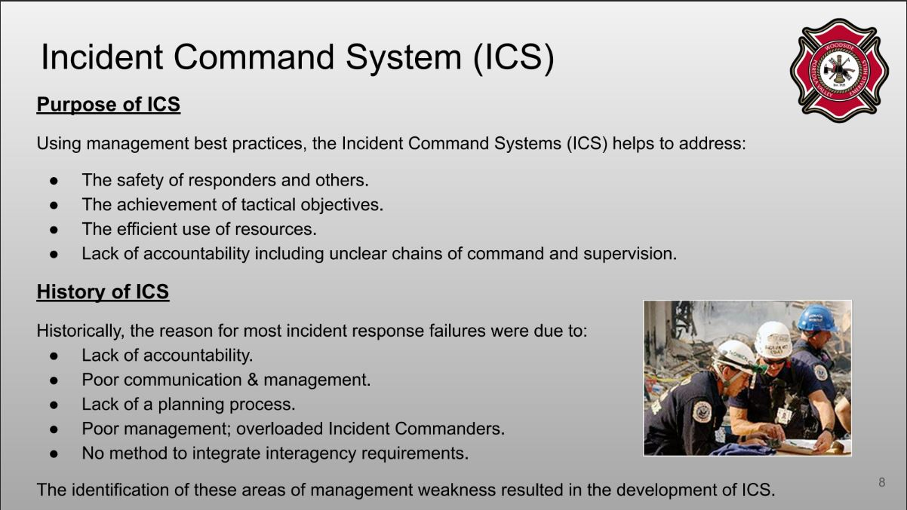

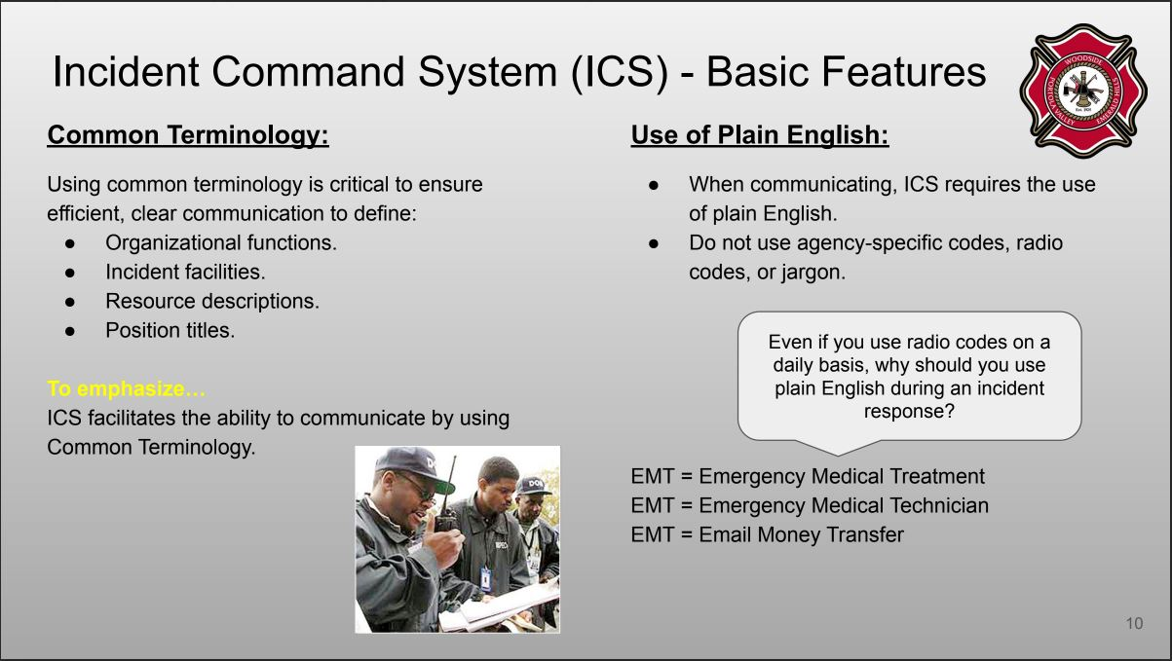
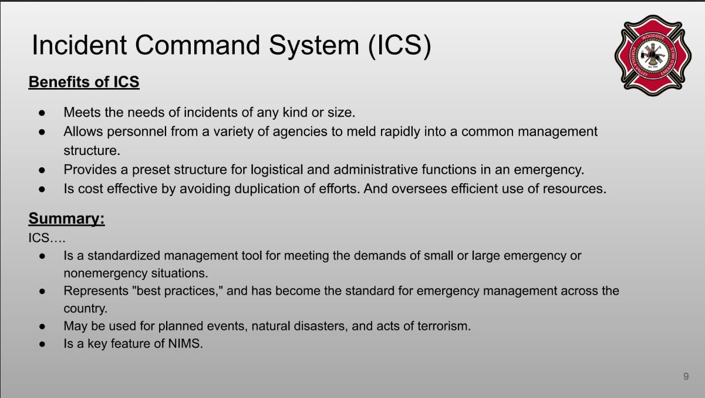
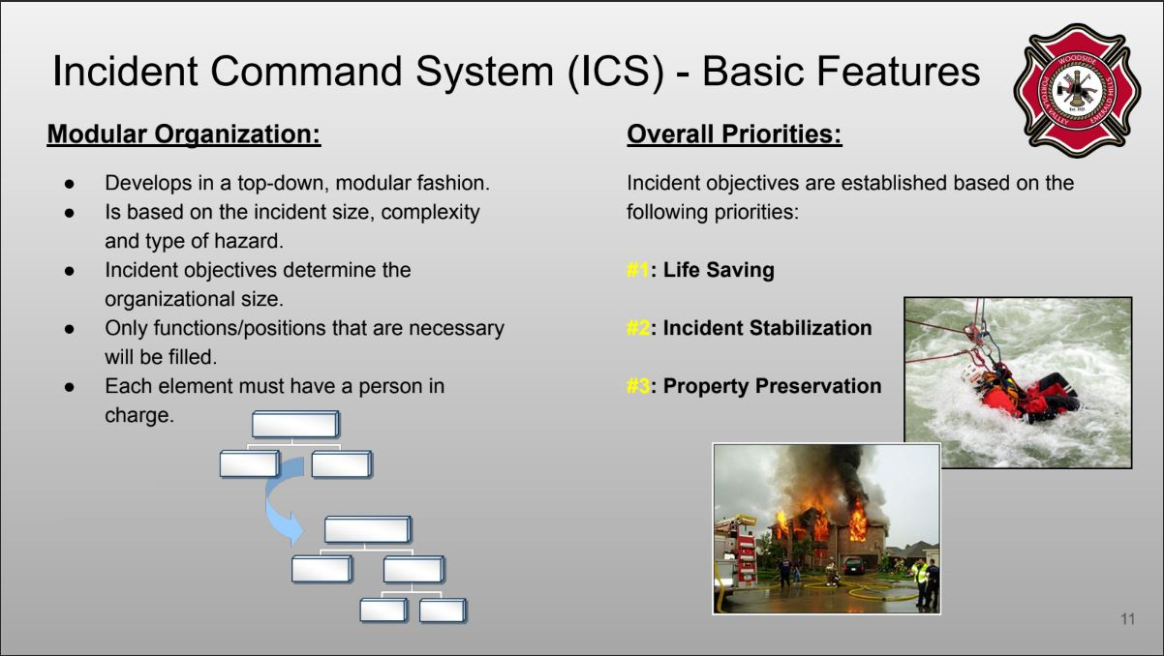
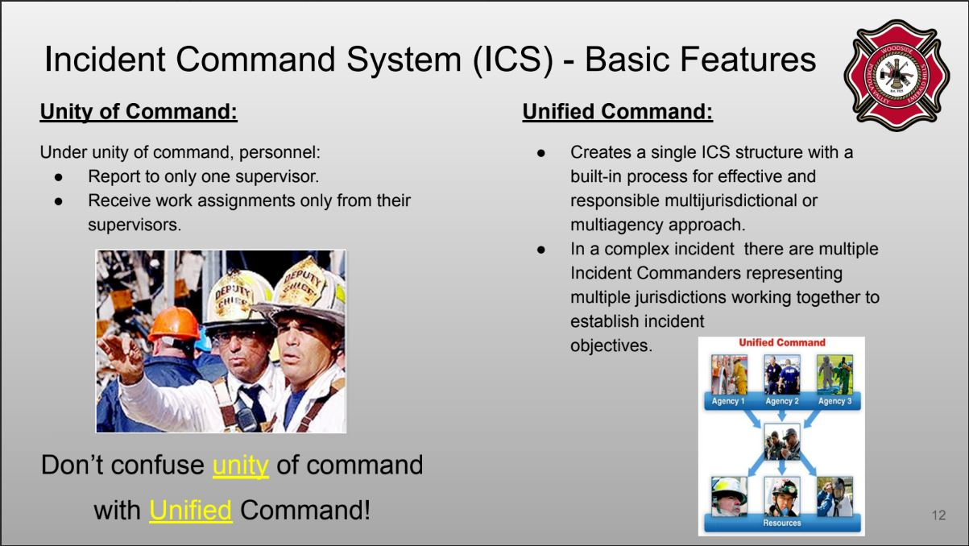
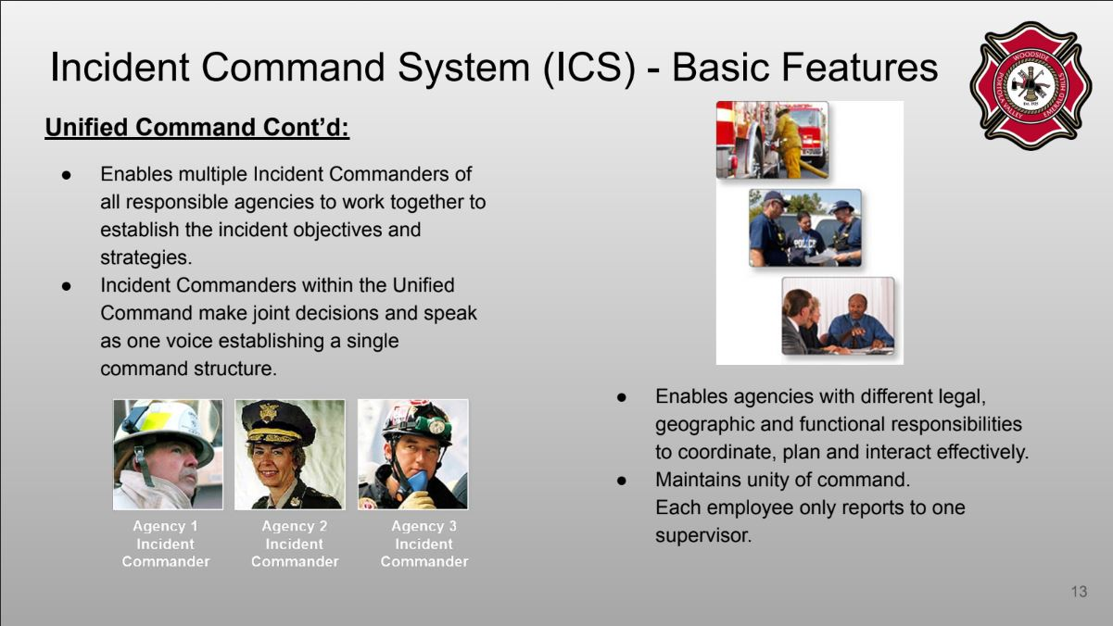

APPENDIX 2 - SHELTER IN PLACE INFORMATION

A Shelter-in-Place location is used when it is safer for individuals to stay indoors during an emergency rather than evacuate. This strategy is often employed in situations such as severe weather, hazardous material releases, or security threats. Shelter-in-Place locations are typically within a building or structure that can provide protection from external threats, such as reinforced rooms or designated safe areas. The emphasis in a Shelter-in-Place scenario is on creating a secure and sealed environment to minimize exposure to external hazards until it is deemed safe to leave.

In case of wildfires, a good shelter in place structure needs to have been prepared with defensible space and home hardening (you can find more about defensible space and home hardening from the IAFC (www.iafc.org/docs/default-source/pdf/rsg-eag.pdf) and the Portola Valley Wildfire Preparedness Committee (www.portolavalley.net/government/town-committees/wildfire-preparedness-committee/three-steps-to-preparedness) and the use of shelter in place should only be used if safe evacuation is not possible. Early evacuation helps everyone.

PVSD and the Sequoias have had extensive preparation in creating safe emergency shelter in place facilities.

APPENDIX 3 - TEMPORARY EVACUATION POINTS

Where to shelter?
In an emergency situation when a dangerous condition arises at your location and it is safe to move to an area which is not hazardous then do so and always evacuate when an evacuation order is issued and transit is safe. In situations when your transit to evacuate is not as safe as sheltering in place (as described in Appendix 2) then move to a shelter-in-place location.
In some situations, there may not be a permanent shelter-in-place location available, or your transit to evacuate may have become blocked -- then you may need to seek a Temporary Evacuation Point.

Temporary Evacuation Points (TEP)
A Temporary Evacuation Point may be a designated location within a building or facility that is designed to provide a safe and secure space for people during an emergency or crisis situation. It serves as a temporary shelter where individuals can seek protection from immediate hazards such as fires, chemical spills, or natural disasters, while awaiting further instructions or rescue.
In the context of a wildfire, where buildings may not be safe, a Temporary Evacuation point refers to a designated outdoor location that offers a temporary safe haven for individuals fleeing from the approaching flames. These areas are selected based on their proximity to low-risk zones, accessibility, and natural barriers that can provide some protection against the wildfire's spread. Temporary Evacuation Points in wildfire situations often include open spaces like parks, fields, or cleared areas with minimal vegetation. They are typically located away from the fire's path, ensuring a greater level of safety for evacuees. Emergency personnel and resources are deployed to these areas to provide necessary assistance, such as medical aid, supplies, and coordination of evacuation efforts. The aim is to provide a secure space where individuals can take refuge until it is safe to proceed to more permanent evacuation sites or until rescue teams arrive.
Here are some general guidelines which Fire Safe Marin recommends during evacuation: (www.firesafemarin.org/wp-content/uploads/2017/03/FIRESafe_MARIN_Evacuation_Checklist.pdf)
- Even during an extreme wildfire, when there may be fire on both sides of the road, you will be safer inside your vehicle than out. Keep the windows rolled up, outside vents closed, turn your lights on, and drive slowly and carefully.
- The best evacuation route is usually the one you know best. Take the fastest paved route. Use all communication means to be informed of up-to-date traffic situations.
- Proceed downhill, away from the fire if possible. Know at least two routes.
- If roads are impassable or you are trapped: take shelter in a building, car, or an open area; park
- In an outside turn if trapped on a hillside; stay far from vegetation; look for wide roads, parking lots, playing fields, etc.
- In general If trapped, you are better protected inside a building or vehicle unless a TEP is at hand.
- Don’t abandon your car on the road if passage is impossible. If you must leave your car, park it off the road and consider other options for shelter.
- Evacuate on foot only as a last resort.
- Don’t evacuate by fire road, uphill, or into open-space areas with unburned vegetation.
- Remain calm - panic is deadly.

APPENDIX 4 - LOCATIONS OF SPECIAL FACILITIES

SCHOOLS

Name | Evacuation Contact | Address | Students
PVSD - Ormondale Elementary School | Adam Lint (Facilities)  650-851-1777 ex 2568  alint@pvsd.net  Roberta Zarera (Superintd.) | 200 Shawnee Pass, Portola Valley | ~ 220  TK - 3rd grade
PVSD - Corte Madera  Middle School | Adam Lint (Facilities)  650-851-1777 ex 2568  alint@pvsd.net  Roberta Zarera (Superintd.) | 4575 Alpine Rd., Portola Valley | ~ 270  4th - 8th grade
Carillon Preschool  (at Christ Church) | Cara O'Connell  650-529-1335 | 815 Portola Rd., Portola Valley | ~45 at any time  Preschool
Windmill School | Jane Garvey  650-851-0771 | 900 Portola Rd., Portola Valley | ~50 at any time  Preschool
Woodland School | 650-854-9065 | 360 La Cuesta Dr., Ladera | 305  Pre - 8th grade
Priory School | Chase Smith  650-851-8221 | 302 Portola Rd., Portola Valley | 375  6th - 12th grade

RETIREMENT AND NURSING HOMES

Name | Evacuation Contact | Address | Population
The Sequoias  Portola Valley | Sue Fairley  (650) 851-1501  SFairley@SequoiaLiving.org | 501 Portola Rd., Portola Valley | 300  Retirement & Assisted Nursing

SPECIAL NEEDS POPULATIONS FACILITIES

Name | Evacuation Contact | Address | Population
The Willow Commons  (Future Development) | TBD | 4388 Alpine Rd, Portola Valley | TBD

APPENDIX 5 - ZONEHAVEN INFORMATION

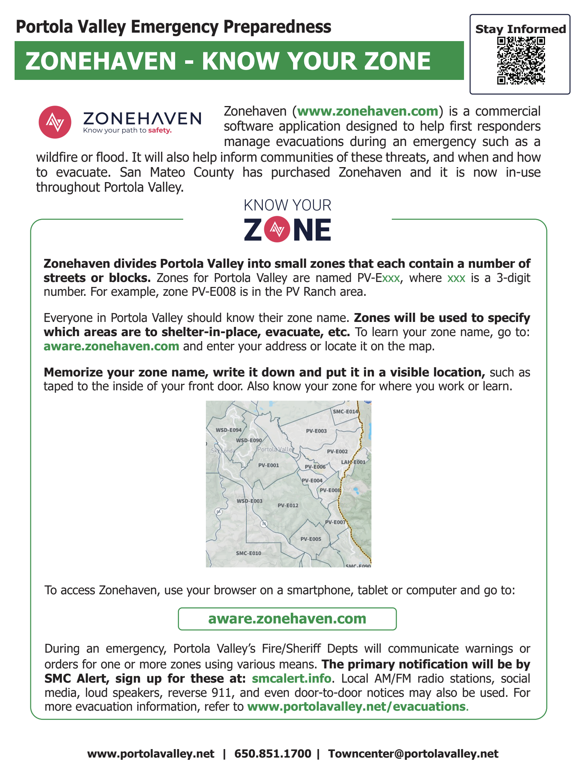

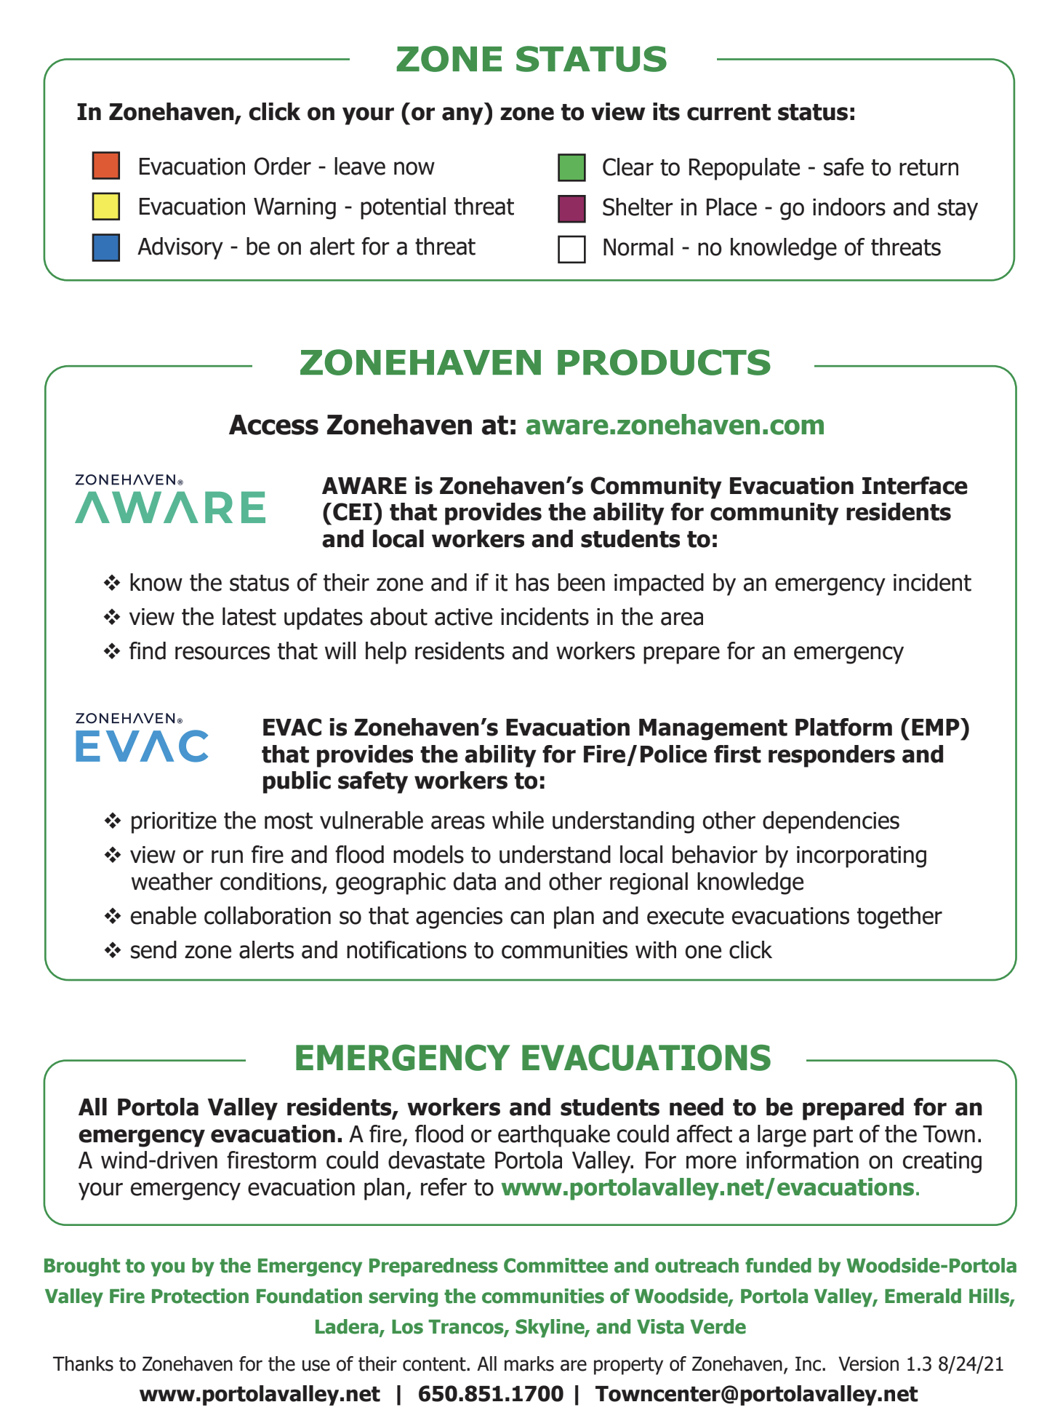

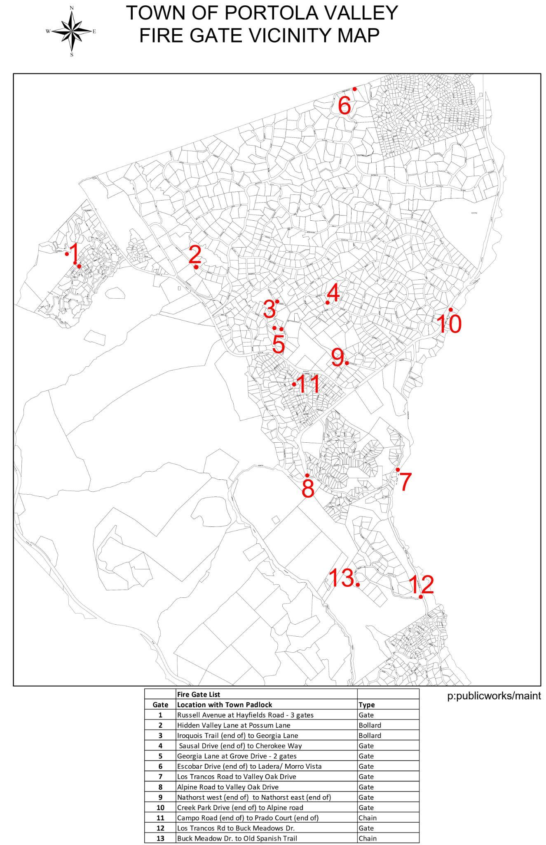
APPENDIX 6 - EMERGENCY GATE LOCATIONS

Gate | Location with Town Padlock | Type |  | Gate | Location with Town Padlock | Type
1 | Russell Avenue at Hayfields Road - 3 gates | Gate |  | 8 | Alpine Road(end of) to Nath | Gate
2 | Hidden Valley Lane at Possum Lane | Bollard |  | 9 | Nathorst west (end of) to Alpine road | Gate
3 | Iroquois Trail (end of) to Georgia Lane | Bollard |  | 10 | Creek Park Drive (end of) to Alpine road | Gate
4 | Sausal Drive (end of) to Cherokee Way | Gate |  | 11 | Campo Road (end of) to Prado Court (end of) | Chain
5 | Georgia Lane at Grove Drive - 2 gates | Gate |  | 12 | Los Trancos Rd to Buck Meadows Dr. | Gate
6 | Escobar Drive (end of) to Nathhorst east (end of) | Gate |  | 13 | Buck Meadow Dr to Old Spanish Trail | Chain
7 | Los Trancos Rd to Buck Meadows Dr. | Gate

APPENDIX 7 - LIVESTOCK EVACUATION SUPPORT AGENCIES

Resources for livestock evacuation for Portola valley:

- San Mateo County Large Animal EVAC
www.smclaeg.org smclaeg@gmail.com 650-684-0616

- Halter Project Animal disaster preparedness + Response
www.HalterProject.org rescue@halterfund.org
James Spencer

San Mateo County Large Animal Evacuation Group (SMC LAEG)
smclaeg@gmail.com www.smclaeg.org 650-684-0616

Following information from
SMC Evacuation Training 2023 - LAEG Presentation by Lori Morton-Feazell (google pdf link)

Mission
San Mateo County Large Animal Evacuation Group’s (SMC LAEG) mission is to provide evacuation services and shelter for large/farm animals in the event of disaster, such as wildfire or flood, or in other emergencies. These efforts include the evacuation of animals, caring for the animals in holding areas after evacuation, and facilitating the return of animals to their owner/agent. SMC LAEG is activated by the San Mateo County Department of Emergency Management, or other first responder unit, and its efforts are staffed by SMC LAEG’s core team members and volunteers.

SMC LAEG is an all-volunteer 501c3. The group also provides preparedness workshops and site inspections upon request.

Activation
STAGE ONE: Initial Contact
Command staff assesses the scope of the incident and the resources needed.

STAGE TWO: Alert
Response teams prepare for deployment.

STAGE THREE: Activation
Per the Department of Emergency Management Operations Animal Care Branch Director, Command Staff notifies response teams to proceed to their designated assignments.

STAGE FOUR: Reunification & Deactivation
The Department Operations Center determines when to deactivate SMC LAEG. Evacuation teams stand down with limited resources held to facilitate the reunification process should extended animal care be necessary.

Offerings
- SMC LAEG provides these training opportunities to our members:
- Trailer Maneuvering and Loading
- Trailer Safety, Maintenance and Specifications
- Large Animal Handling – BASIC and ADVANCED
- HAM Radio Operation and Set Up
- Activation Drills – Start to Finish
- Interagency Training with SMC First Responders and other Community Resource Teams
- Mutual Aid Opportunities
- Monthly General Meetings for all members
- Standard Operating Procedures (SOP) covering member protocol, event processes and operation

Preparation
- Be an aware owner
- Plan escape routes ahead of time – EVACUATE EARLY if you can
- Train your animals ahead of time
- Do your training on a regular basis
- Inspect your surroundings & equipment and do regular maintenance
- Keep all your information updated
- Keep “Go Kit” updated
- Keep family, friends & facility management updated
- Practice your plan
- ...Practice your plan again!!

APPENDIX 8 - EVACUATION ROUTES

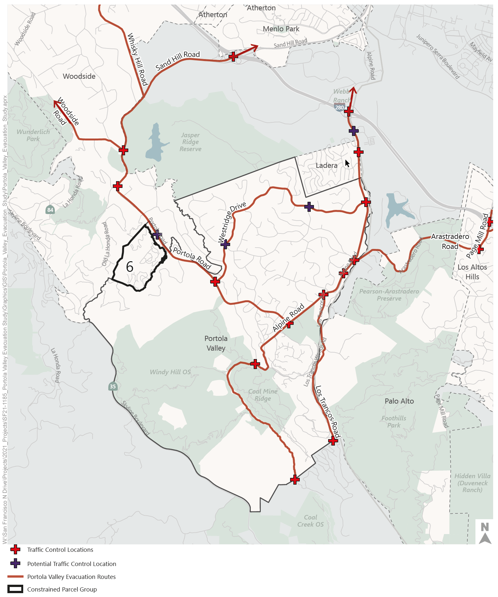
Due to unforeseen circumstances or hazards, it may be necessary to alter traffic control points or routes of egress. All residents should be prepared to use an alternate route or retreat to a shelter in place location. No evacuation route in the chaos of a fire or other hazard can be guaranteed to be open. Residents are encouraged to evacuate as early as possible during a warning to avoid blockages during an order

The complete Portola Valley Wildfire Traffic Evacuation Capacity Study done in 2022 can be found at www.portolavalley.net/home/showdocument?id=16378&t=63794445.

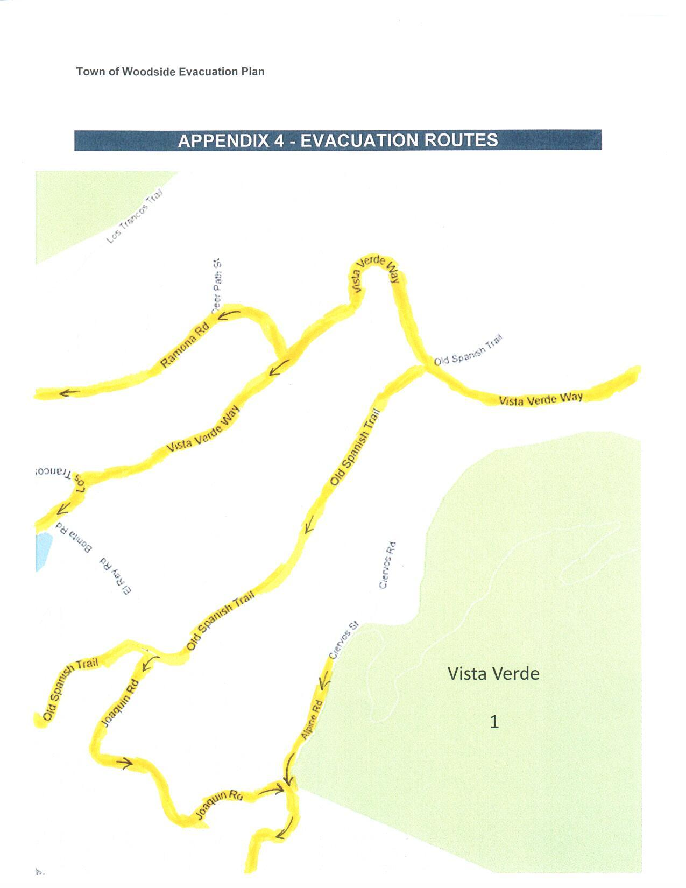
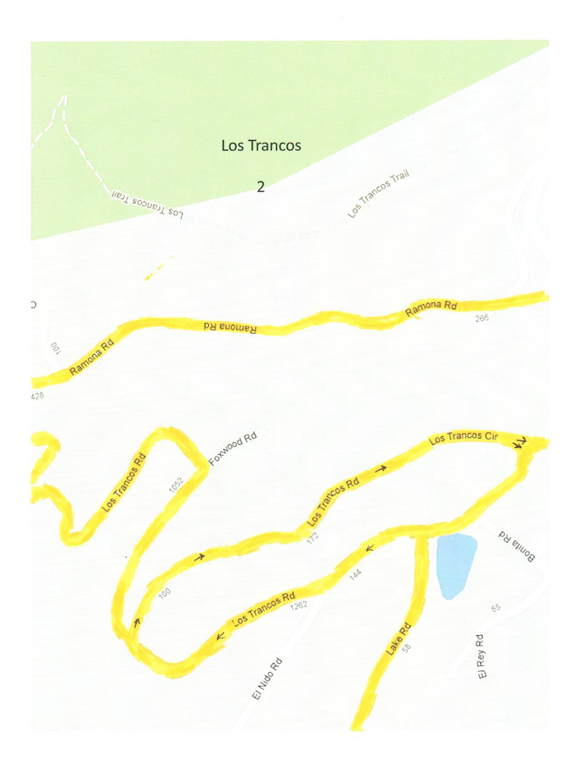
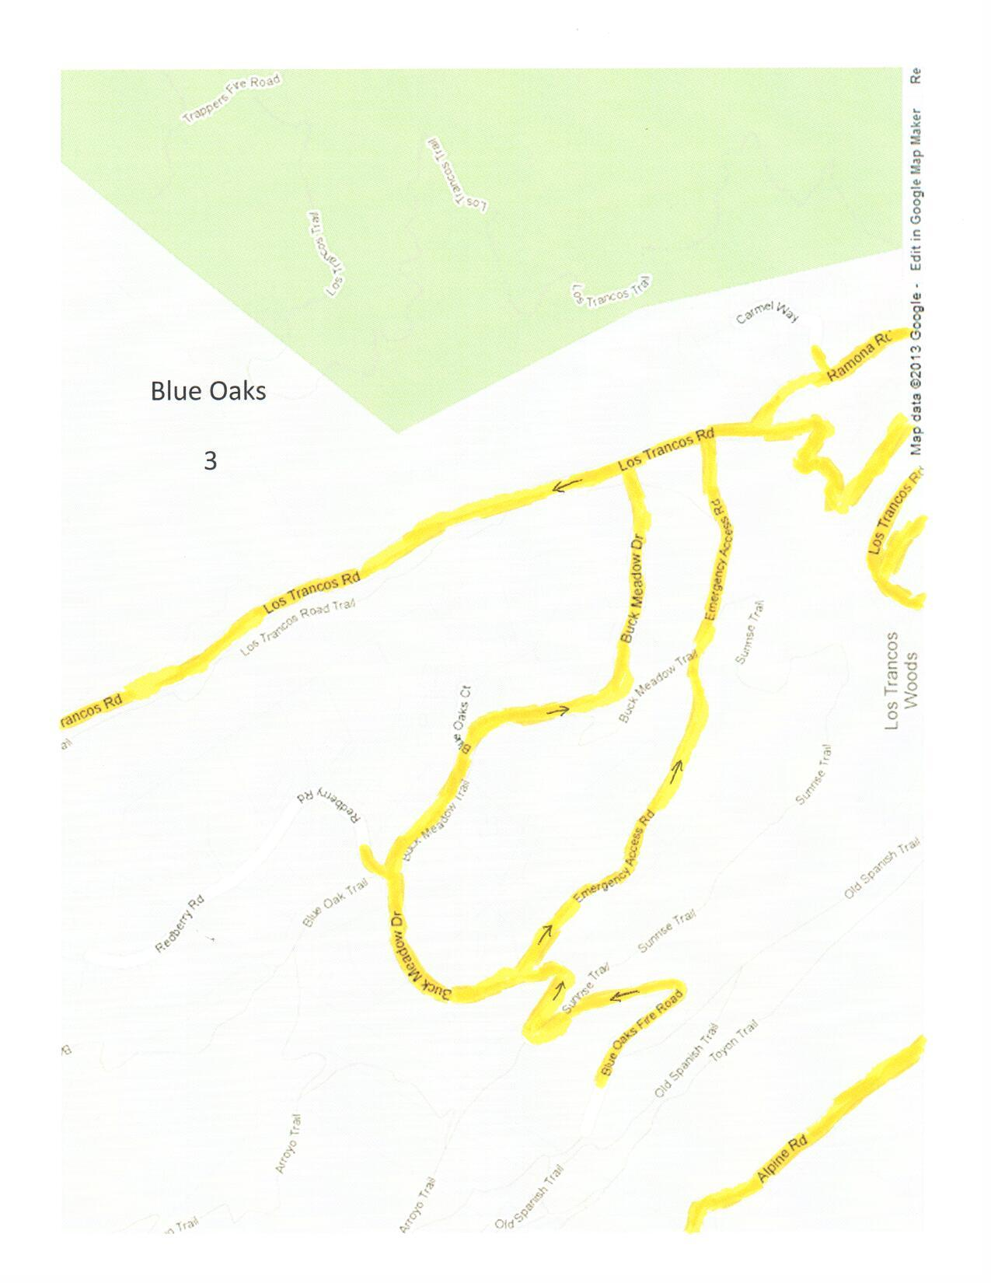

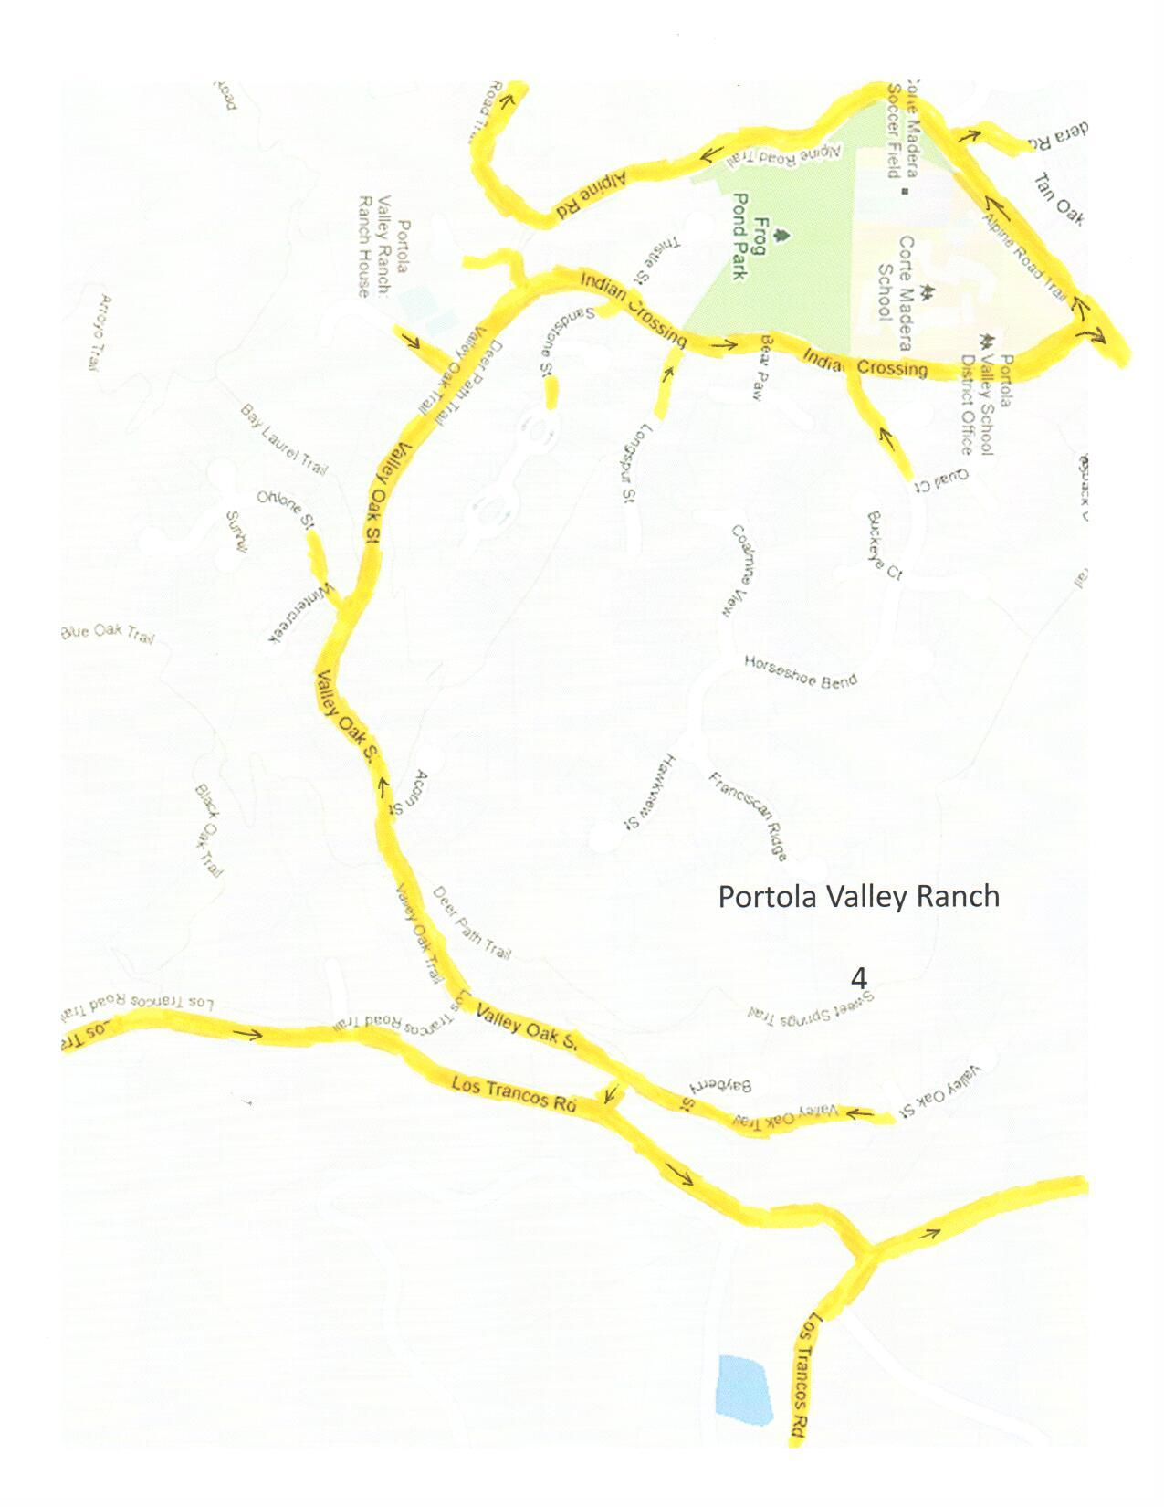

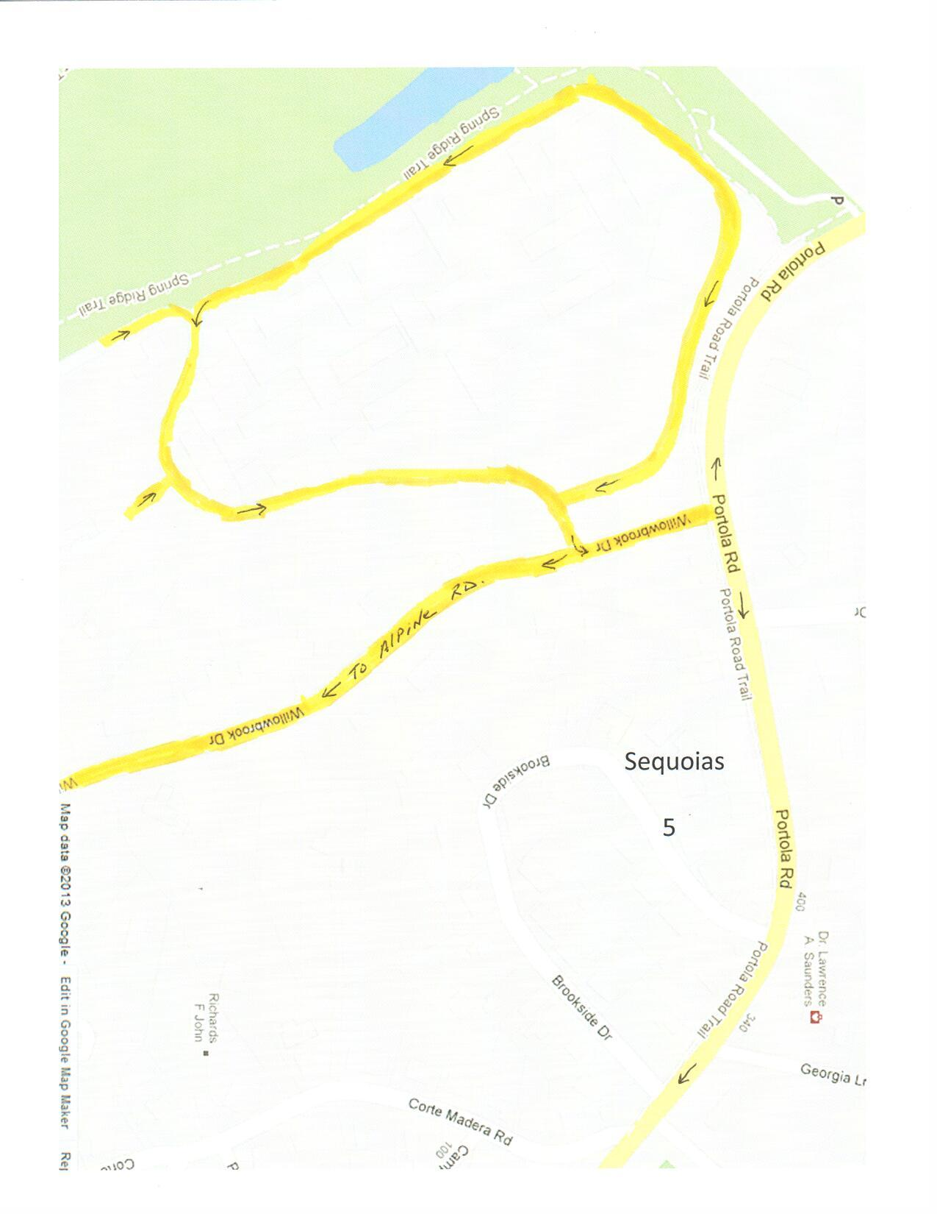
Emergency Exit From Sequoias Into Windy Hill Parking lot.

